AIM: To load a student dataset from a CSV file, check and handle missing values, select numerical columns, and normalize the data using the StandardScaler class in Python.

ALGORITHM:
- Start the program.
- Import the Pandas library and StandardScaler from Scikit-learn.
- Load the student dataset from the data.csv file.
- Remove extra spaces from the column names.
- Display the first five rows of the original dataset.
- Check for missing values in the dataset.
- Fill missing numerical values with their respective column means.
- Select the numerical columns: Hours studied, Attendance, Assignment, and Marks.
- Create a StandardScaler object.
- Normalize the selected numerical data using fit_transform().
- Convert the normalized data into a Pandas DataFrame.
- Display the first five rows of the normalized dataset.
- Stop the program.

OUTPUT:
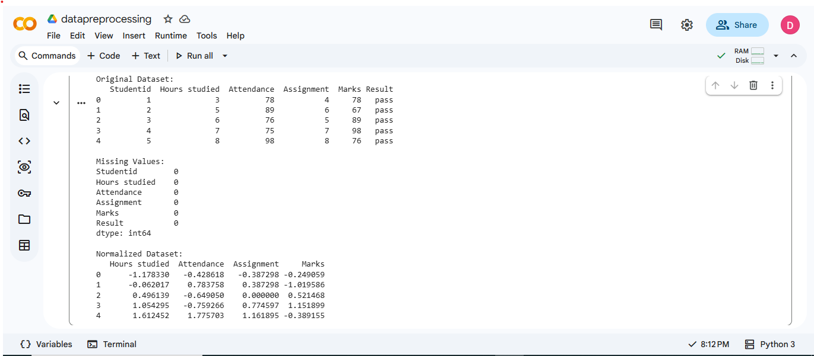

RESULT: Thus, the student dataset was successfully loaded, missing values were checked and handled, and the numerical data was normalized using the StandardScaler in Python.

